**DAILY ONLINE ACTIVITIES SUMMARY**

|  |  |  |  |  |  |  |  |  |
| --- | --- | --- | --- | --- | --- | --- | --- | --- |
| **Date:** | **11/06/2020** | | | | | **Name:** | **VANDANA** | |
| **Sem & Sec** | **IV sem & B section** | | | | | **USN:** | **4AL18CS095** | |
| **Online Test Summary** | | | | | | | | |
| **Subject** | | **-** | | | | | | |
| **Max. Marks** | | **30** | | **Score** | | | **-** | |
| **Certification Course Summary** | | | | | | | | |
| **Course** | **Introduction to Ethical Hacking** | | | | | | | |
| **Certificate Provider** | | | **Greatlearning academy** | | **Duration** | | | **4.0 hours** |
| **Coding Challenges** | | | | | | | | |
| **Problem Statement1:** Write a Java Program to Segregate Even and Odd numbers. | | | | | | | | |
| **Status: Executed** | | | | | | | | |
| **Uploaded the report in Github** | | | | | **YES** | | | |
| **If yes Repository name** | | | | | **Online-coding** | | | |
| **Uploaded the report in slack** | | | | | **YES** | | | |

Online Test Summary: No internals conducted today.

Online Certification Course Summary: Today I have enrolled for the new certification course that is Introduction to Ethical Hacking. In today’s session I have learnt about the Career and Growth Ladder in Ethical Hacking and also about Domains and Process Implementation under Ethical Hacking.

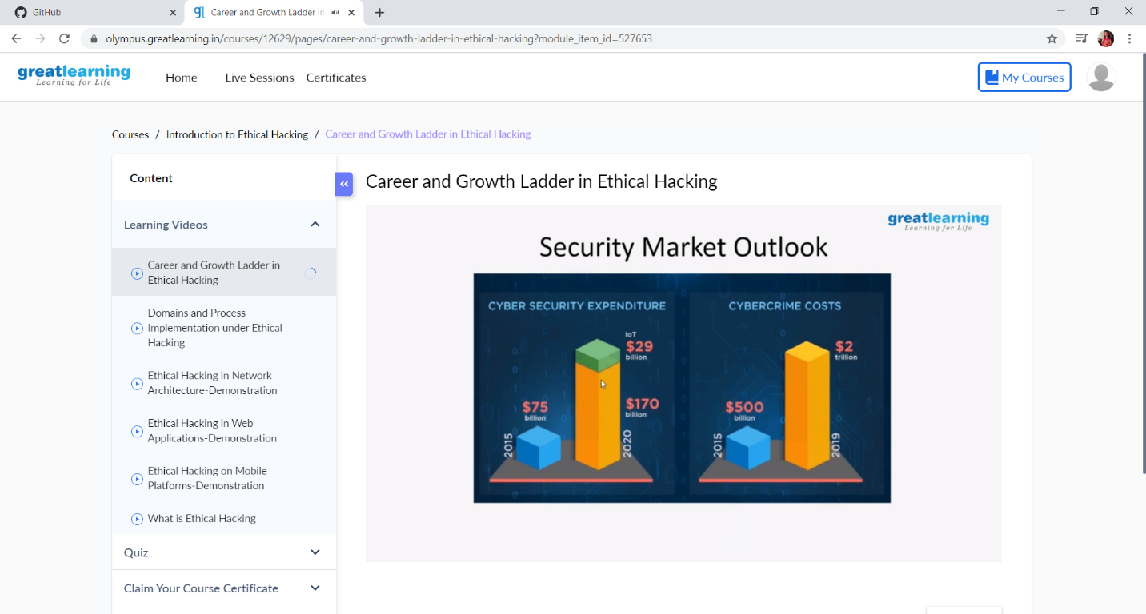

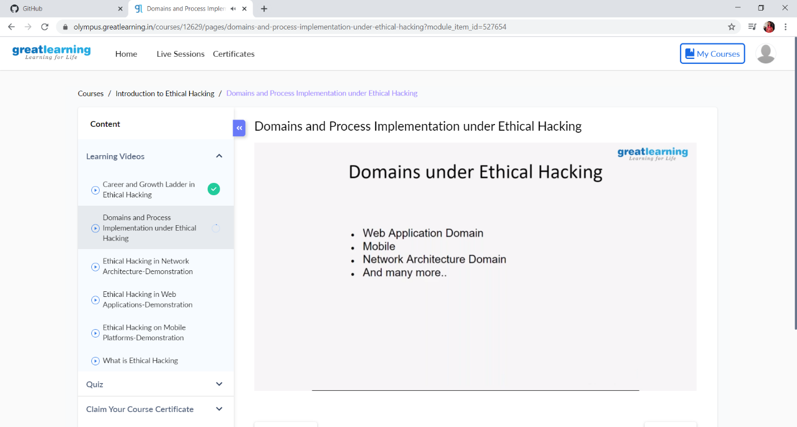

These are the snap shots of today’s sessions.

Online Coding Summary: **Today I had received one program from prof. Shilpa CSE Dept.The program is mentioned above in the coding challenges(pg.01). I have also uploaded it to my Github repository.**

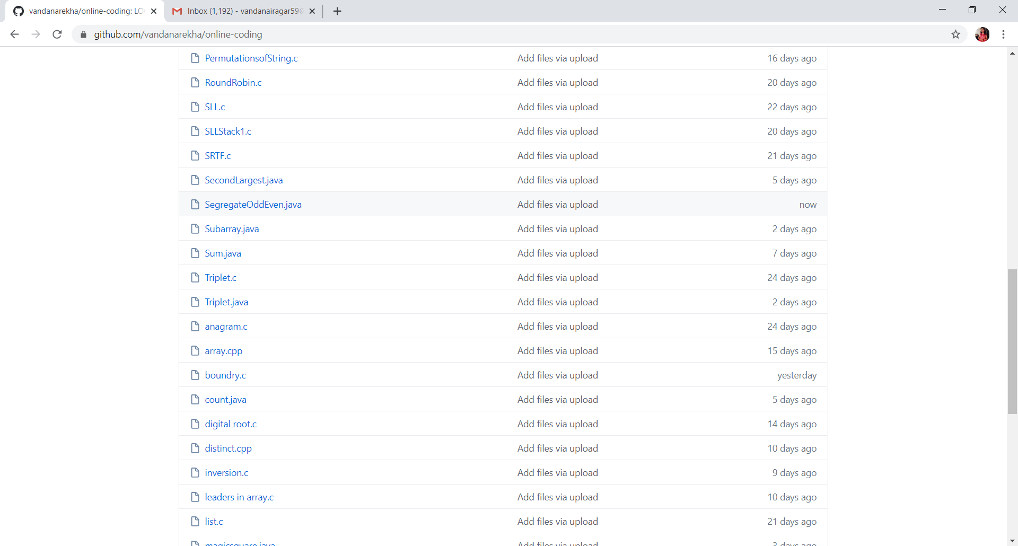

It is the snap shot of my repository were I have uploaded the code. File name is SegregateOddEven.java